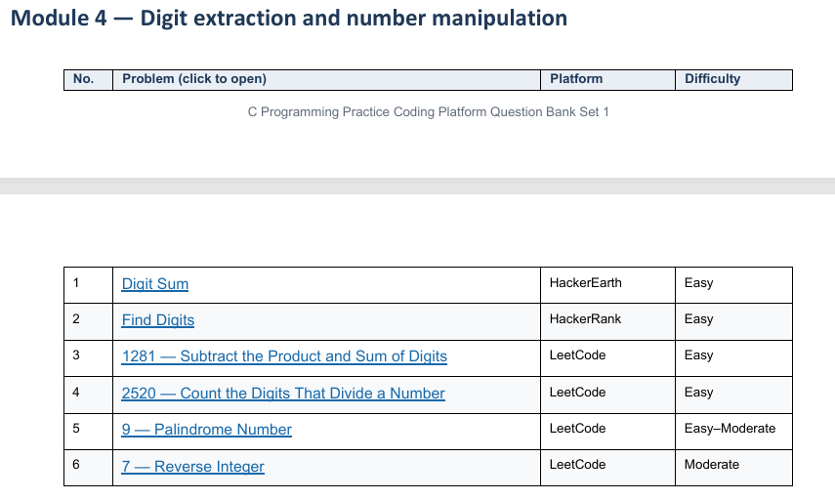
1 Digit Sum HackerEarth
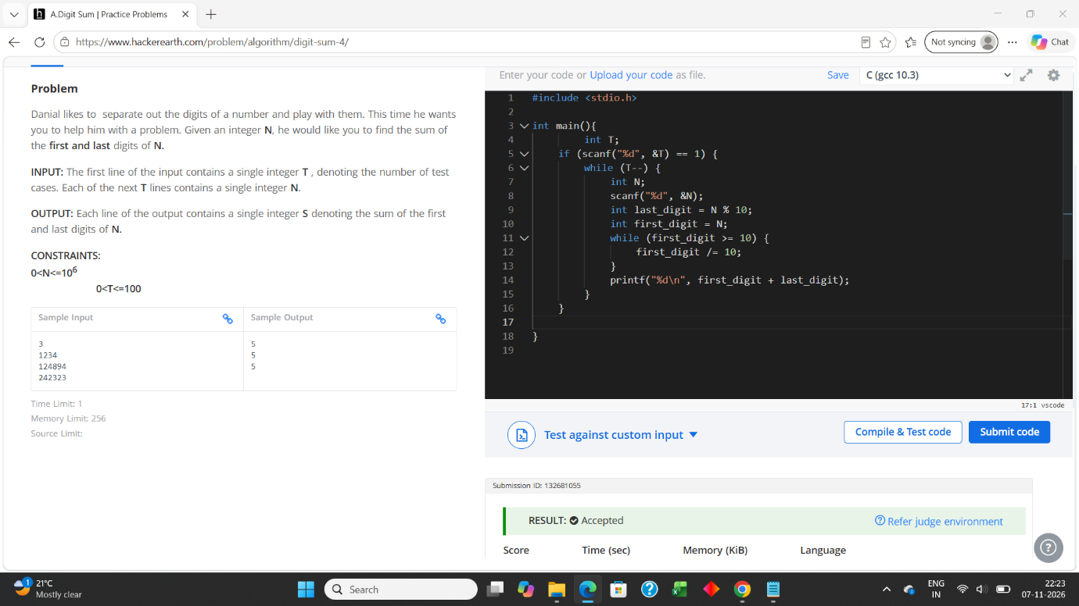

2 Find Digits HackerRank
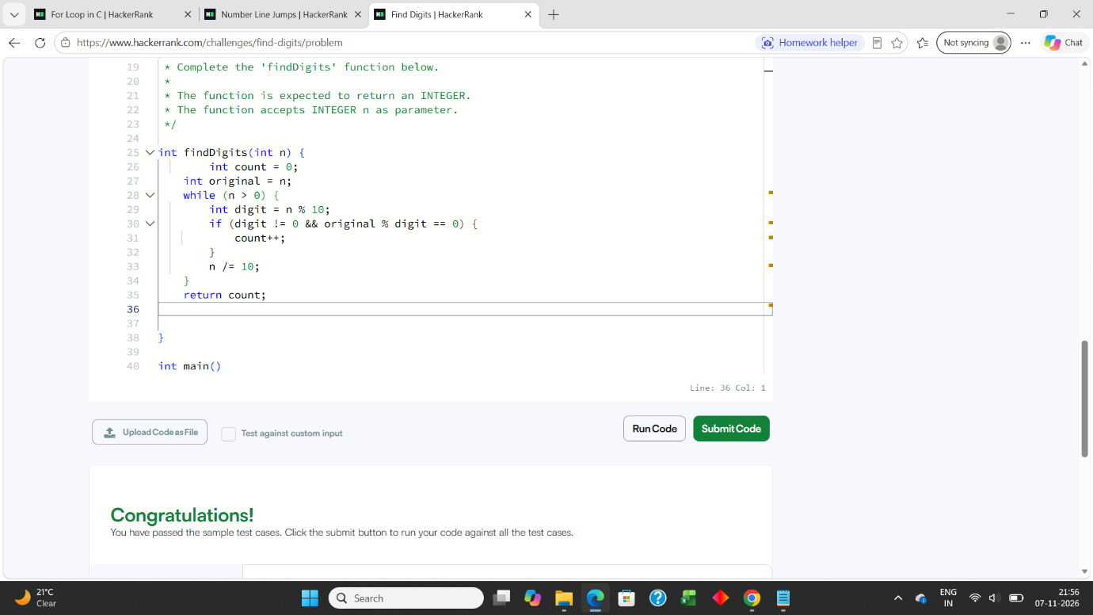

3 1281 — Subtract the Product and Sum of Digits LeetCode
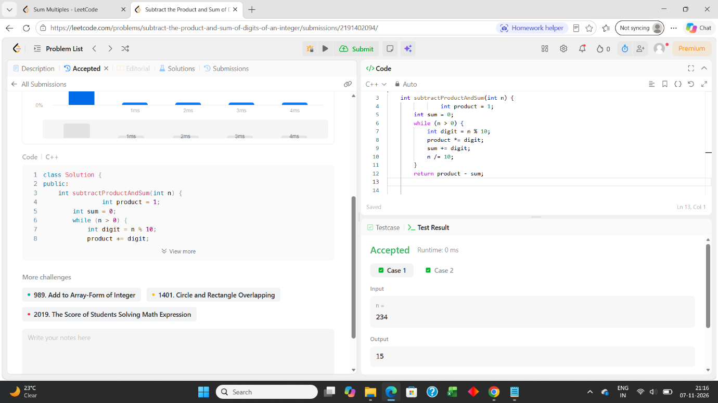

4 2520 — Count the Digits That Divide a Number LeetCode
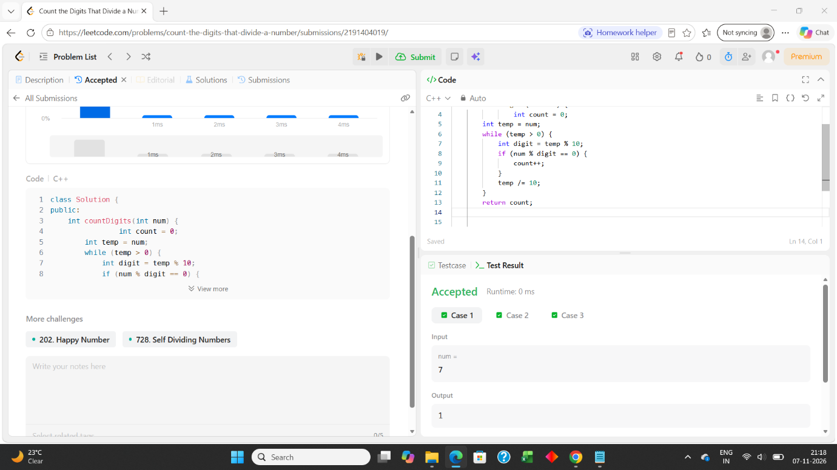

5 9 — Palindrome Number LeetCode
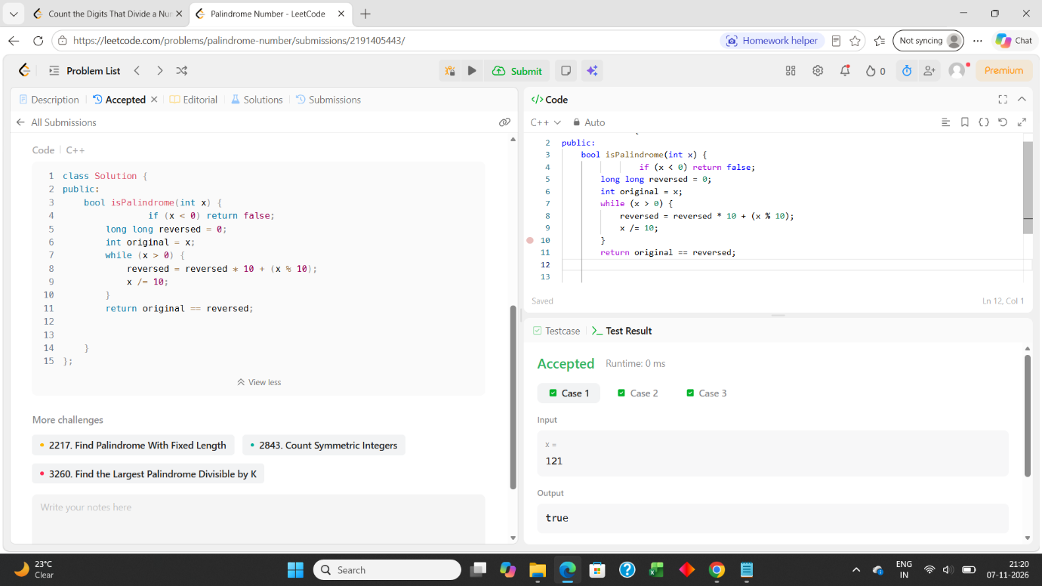

6 7 — Reverse Integer LeetCode


